Evergreen's Rotary club a strong player in the community
By Josie Klemaier
YourHub Reporter
POSTED: 03/05/2015 12:01:00 AM MSTADD A COMMENT

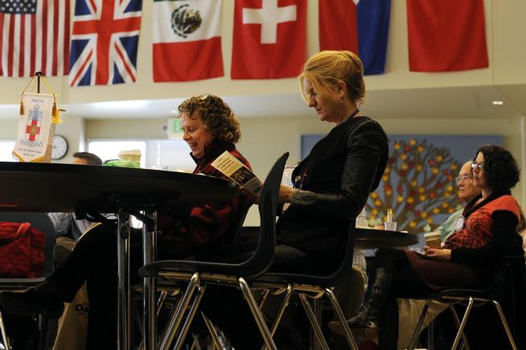
Beth Andersen, center, reads a pamphlet as she listens to a guest speaker during a weekly meeting of the Rotary Club of Evergreen on Feb. 27 in Evergreen. (Anya Semenoff, YourHub)
EVERGREEN —The Rotary Club of Evergreen has topped 100 members since last July.
It's not a milestone — membership has fluctuated above and below that number — but it ranks the club as one of the larger in its region and helps make it one of the Evergreen community's most active nonprofits.
"The Rotary motto is 'Service Above Self,' " said Rotary of Evergreen president Sam Smith.
"Believe me," he said, emphasizing the conviction he feels about the sentiment expressed in the maxim.
Rotary is an international civic organization of local clubs that focus fundraising and service efforts in their communities and across the globe, a project spectrum that is well-represented in Evergreen.
The club hosts the annual Mountain Area Home and Garden Show each April, now in its 10th year. In 2014, it started an adult literacy effort called Mountain Reads and hosted a second annual golf tournament that benefited 27 local nonprofits, among other local projects. Many members travel overseas for projects related to medicine, microloans, water purification, education and disaster relief.
In fiscal year 2014, the club gave $41,978 to local organizations and efforts, and $24,443 to international causes — nearly $20,000 more overall than in 2013.
"I think they've become extremely active in the community," said Betsy Hays, interim president for the Evergreen Chamber of Commerce. The Rotary Club of Evergreen is one of 11 nonprofits nominated for nonprofit of the year in the chamber's annual honoree ceremony March 5.
People join the Rotary Club of Evergreen for its sense of community in a town that attracts new residents and families, said Laurie Romberg, the club's communications chairwoman.
"Because you have this common foundation, we can say we are a community," Romberg said.
Since starting in 1985, Evergreen's Rotary has spawned the Rotary Club of Mountain Foothills, which has 55 members of its own and does the Ice Melt Contest on Evergreen Lake each year. Evergreen also partners with nearby Rotary Club of Conifer on the home and garden show.
There is an age gap in the 20-40 age range, and there is a universal understanding that people such as young parents and college-aged adults are less likely to have time to be as involved as most members.
To help keep participation high, the club has lifted strict attendance requirements in recent years to account for members' busy lives, and it is focusing on increasing its presence online. An "eClub" chartered in 2002 is one of this year's fastest-growing clubs.
Programs like the high school Rotary Interact Club and Rotary Youth Leadership Awards, a scholarship-based summer camp, are helping create a new generation of Rotarians.
Ron Catterson is the liaison for Evergreen High School's Interact Club, which has 40 to 50 students. While many of them come for the free pizza, he said, they also become involved and excited about the volunteering.
"Schools are looking for consistent community service and leadership," he said. "If they get involved with Interact, they have the opportunity to do both of those."
Barbara Scripps is a longtime member and past president, and said she has seen youth become second- and even third-generation Rotarians.
"If they were touched by Rotary in middle school or high school," she said, "they are more likely to return in their adult lives."
Josie Klemaier: 303-954-2465, jklemaier@denverpost.com or twitter.com/JosieKlemaier
Rotary club of evergreen
When: 7 a.m. Fridays
Where: Evergreen Country Day School, 1093 Swede Gulch Road in the Evergreen area
More information: evergreen rotary.org

