Evergreen Rotary helping the Haitian-people
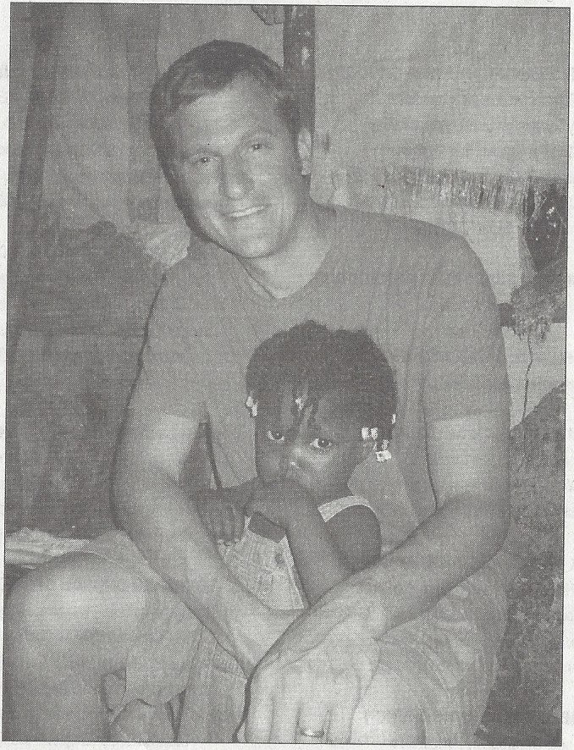
Newest Rotarian is director of · group that assists island country
How to help •• •
What:Party with a purpose: a night to support the work of FIDA in Haiti
When:7to 10:30 p.m. Nov. 17
Where: Bistro Colorado, 1552 Bergen Parkway, No.305, in Evergreen
Tickets:$60
More info: patrick.bentrott@fida-pch.org, 303-523-4989, www.fidaus.org.
BY KEVIN M.SMITH
For the Courier
Haiti has a special place in Patrick Bentrott's heart.
He and his wife were missionaries there from 2008-2010
when the earthquake hit.
Bentrott is also the newest member of Evergreen Rotary.

"The timing is kind of interesting," Bentrott said. He had been a Rotary member just one week when
Hurricane Matthew hit the small island country.Bentrott had been asked to join Rotary because members were looking for someone to improve the club's international outreach.
Bentrotthas been executive director of the U.S. branch of FIDA for the past 18 months. As executive director, he started the U.S. extension of the Canadian organization.
1 FIDA is an acronym for the Foundation for International Development Assistance, and its focus is forming coopera­ tives to empower sustainable communities in Haiti.
"We work with a Haitian group of agronomists and ag techs and educators -and they're with an organization called Productive Cooperatives of Haiti -so we have Haitian staff on the ground, and they're the ones who forge relationships with communities," Bentrott explained. "And what we have our staff do is essentially is to work with communities that are motivated to advance themselves economically through something pertaining to agriculture."
Bentrott said FIDA's main work is helping communities establish agriculturaJ cooperatives.
"Choose their leaders, provide them training in the coop­ erative and maintenance and principals ... once they have that structure in place, we invest in sustainable agriculture projects,"Bentrott said. "And that can range from irrigation
.

,;;

Photo provided
EVERGREEN ROTARIAN PATRICK BENTROTT with
a Haitian child.
systems to poultry production and animal husbandry." FIDA also provides adult literacy courses.
He said if the people take ownership of the projects, they will work harder to maintain them.
"The philosophy of FIDA really centers on this idea that the development must be in the hands of the people," Bentrott said.
In the wake of the hurricane, FIDA is providing food
and hygiene kits in addition to clean water and cholera prevention. FIDA has focused on Duchity, in the southwest peninsula region where the eye of the hurricane swept through. FIDA U.S. had already set up three cooperatives with more than 3,000 members there.
Bentrott said roughly 90 percent of those in Duchity have lost their homes, 100 percent of the crops were destroyed and at least half of the live"stock was killed.
"Our long-term plan for this community involves rebuilding homes, replanting crops, animal husbandry and further agricultural education," Bentrott wrote in an e-mail to Rotarians.
As of Oct. 14, Evergreen Rotarians had donated nearly
$2,000 to FIDA for hurricane relief efforts.
"They really jumped on the opportunity to be in solidar­ ity with the Haitian people and help them out in this time," Bentrott said.
A fund-raiser for FIDA will be held from 7 to 10:30 p.m. Nov. 17 at Bistro Colorado, 1552 Bergen Parkway, No. 305, in Evergreen. Tickets are $60 each.
Bentrott said he'shappy to call Evergreen home. He and his wife lived in Denver for four years before going to Haiti for missionary work. When they left, they were ready for a quiet, mountain setting.
"Port au Prince w3:s a really intense place to live," Bentrott said.

